Customer Service / Service Desk Module Changes in release 7.1

Starting with release 7.1.1 the module previously known as Customer Service and now re-branded as Service Desk has been updated to provide significant extra functionality in the processing of support issues, including two new views.
Views from left to right are Inbox, Card, List and Detail…
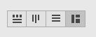
The Card View operates similarly to the existing Card View in Opportunities, providing an easily interpreted visual representation of tickets’ processing status.
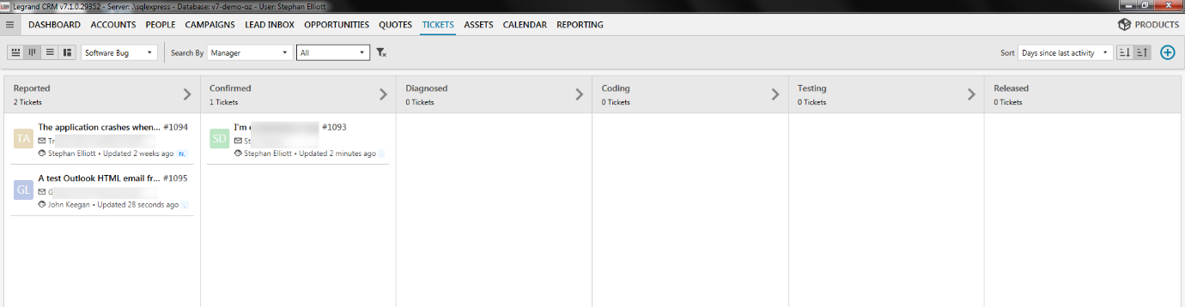
Tickets can be migrated between processing stages by use of drag and drop. In addition each card has a link to allow editing of the ticket, plus the traditional context menu option to perform various actions.
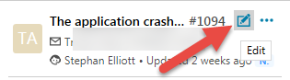
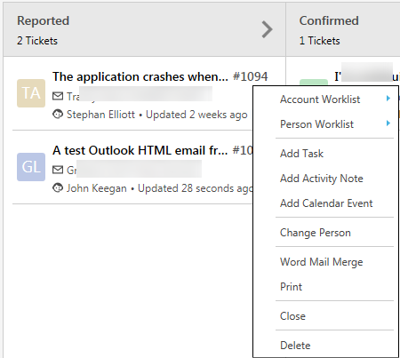
The detail view has been considerably altered to provide a view of all activities in the life of the ticket and a summary of the ticket’s properties.
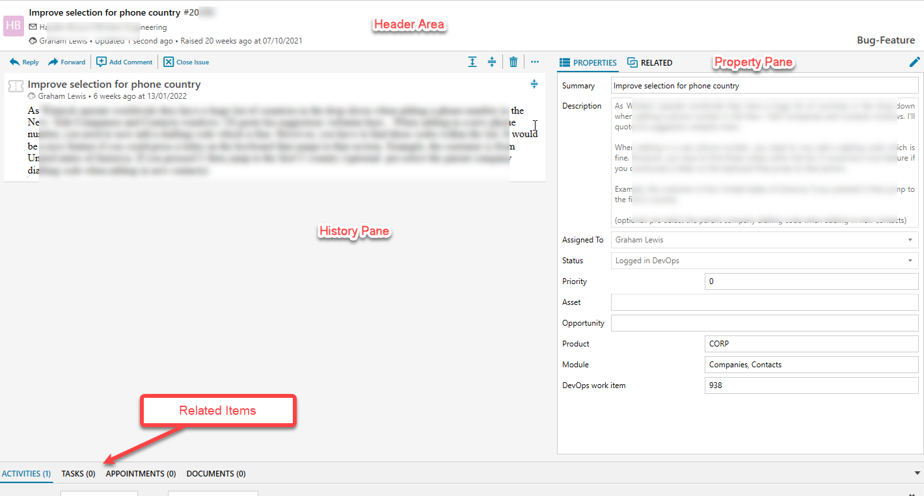
- The Header Area provides basic detail of the ticket such as the contact, the assigned user, the type and the last activity
- The Property Pane shows the details of the ticket such as summary and description and its current status. This pane includes the custom fields defined for the ticket record type in the custom ticket view.
- A second tab in the Property Pane area shows the most recent completed activities and items scheduled
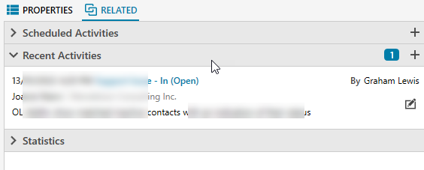
- A link in the Property Pane header allows editing of ticket properties
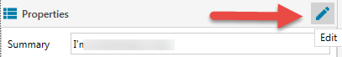
- The History Pane shows activities and emails relating to the ticket in a reverse chronological order. At the top of this pane a series of action links are provided.
- In addition, you can expand and collapse all the individual activity record panes, delete the ticket (if the relevant permission is granted) and perform various actions via a context menu…
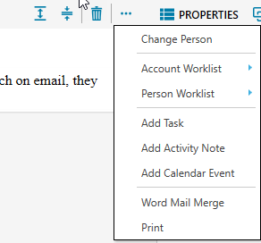

A significant addition is the provision of a Mail Processing view. Enabling this function is optional, but we believe it provides a significant improvement to the customer support process if you do so.
It operates similarly to the Lead Inbox function in allowing the CRM to download emails that arrive at a dedicated support email address. Once enabled, incoming emails are downloaded every 5 minutes to the Inbox view; you can in addition launch a retrieval manually. Emails that are replies to an existing ticket are tracked and link to the ticket, they can be viewed using the ‘New Replies’ link on the Inbox menu.
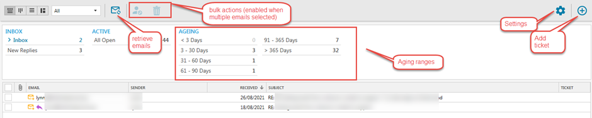

Settings in this view allow specification of the email address to be monitored, whether to send an automatic acknowledge mail to the contact when a ticket is created (and allow editing of the template for that mail), whether to tag new tickets, plus the intervals (up to 8) to be used in aging tickets.
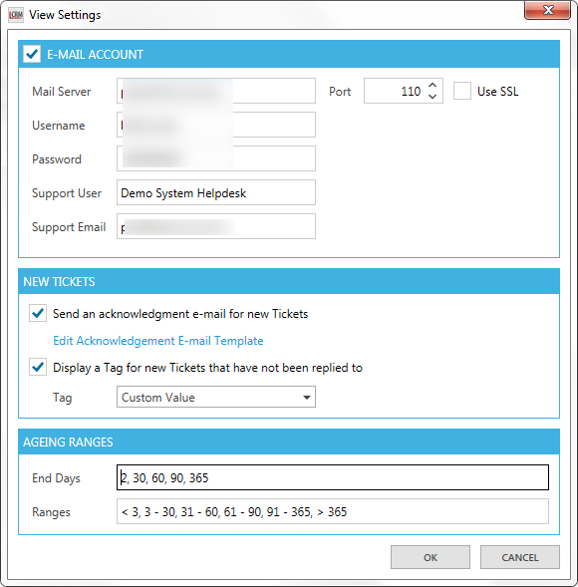
When setting up the e-Mail Account details please note that you need to specify mail server name, username & password for the incoming (POP) mail server. This is not the same as the settings used for outgoing (SMTP) mail that you would have entered on the User Preference / E-Mail Settings window. Your IT Support people or email provider can advise you as to the correct settings to use. The Support User and Support Email fields specify the values to be used on outgoing emails when replying or forwarding tickets. Please note that for correct tracking of emails to and from the support email address that on the User Preference / E-Mail Settings window the ‘Send Direct’ method must be used (i.e. you cannot use the legacy ‘Send via Outlook’ option).
Important: Please also be aware that all mails that arrive at the specified email account will be downloaded to the Legrand CRM system and will no longer be available for processing using your mail program such as Outlook.
If you wish to still be able to read and reply to these mails using your mail program, as well as processing them in Legrand CRM, we suggest that you set up a new mailbox, using an address such as support.download@mycompany.com, which you specify in the settings. Then configure the existing mail account to auto-forward all incoming mails, whilst retaining a copy, to that account. That way the mails will remain available for processing in a mail program. Once again, your IT Support people or email provider are the ones to advise the details of how to set this up and we are of course available to provide advice or clarification via support@legrandcrm.com.

When an email is selected in the list its detail is shown in the pane below.
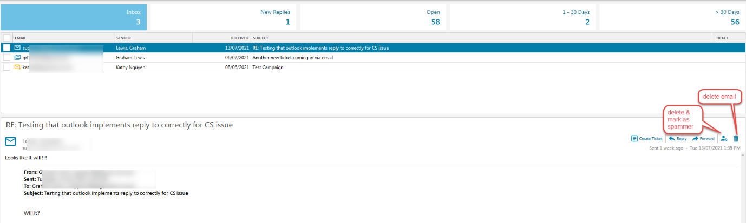

Actions available for the email are
- Create Ticket, this will open a new ticket window with your user selected as the assigned owner (this can be changed using the drop-down selector)
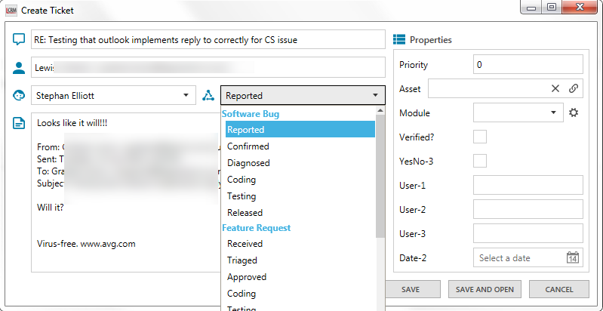
The email subject will be entered as the ticket title, and the body as description, both can be edited as required.
The type and stage assigned when the ticket is created can be selected. Note that a ticket type cannot be changed once the ticket is created.
The contact will be assigned as that matching the email address of the sender if there is only one such match in the system. If there are either multiple matches or no match a contact selection window will be shown which will allow you to link it to a chosen contact or, in the no match case, create a new contact.
- Reply and Forward will open a send email window, for Reply the To: address will be the incoming email address.
- Create Contact will be available if the email has originated from an email address that is not associated with an existing contact in the CRM.
- Delete email will remove the mail from the system, with no further processing
- Delete Spam will remove the email from the system and add the incoming email address to a blacklist, resulting in any future incoming emails from that address being silently dropped.
- The resulting blacklist can be managed using a new entry on the menu…
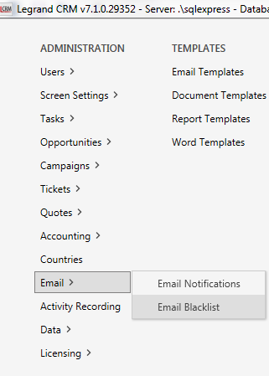 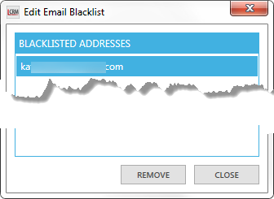
…which will enable email addresses to be unblocked.
- Access to both the Delete Email and Blacklist Management functions is controlled by new permissions in the Customer Service category
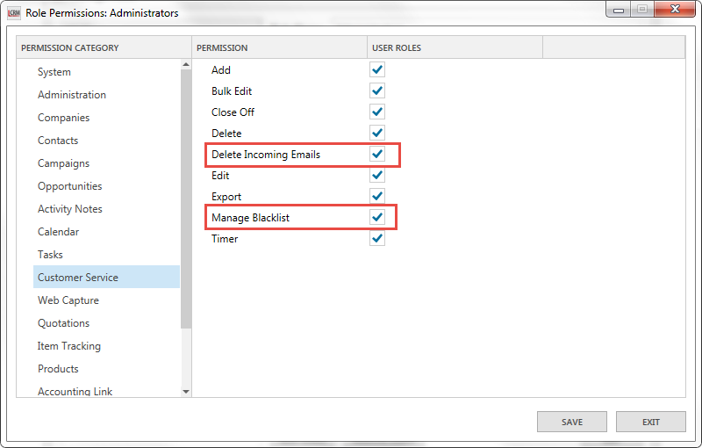

Selection of incoming mails using their checkboxes in the list will enable the bulk Delete and Spam Delete function buttons allowing a rapid processing of unwanted emails…
